Features of Java

1) Simple
Simple syntax. No pointers, no multiple inheritance with the classes which causes ambiguity error. For almost every task API (Application Programming Interface) is available; Programmer just need to know how to use that API.

2) Object Oriented
Java is strong object oriented as it does not allow features like global data, friend function which are against OOP principles.

3) Automatic Garbage Collection:
Automatic garbage collection is the process of looking at heap memory, identifying which objects are in use and which are not, and deleting the unused objects. An in use object, or a referenced object, means that some part of your program still maintains a pointer to that object. An unused object, or unreferenced object, is no longer referenced by any part of your program. So the memory used by an unreferenced object can be reclaimed.

3) Robust
Robust means strong. Java puts a lot of emphasis on early checking for possible errors, as Java compilers are able to detect many problems that would first show up during execution time in other languages.
It provides the powerful exception handling and type checking mechanism as compare to other programming languages.

4) Platform Independent
Unlike other programming languages such as C, C++ etc which are compiled into platform specific machines. Java is guaranteed to be compile-once, run-anywhere language.
On compilation Java program is compiled into bytecode. This bytecode is platform independent and can be run on any machine. Any machine with Java Runtime Environment can run Java Programs.
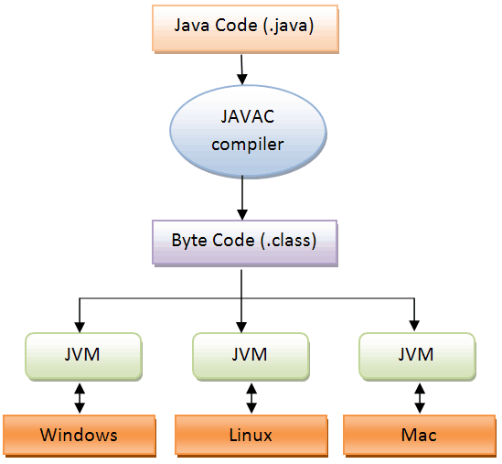

5) Secure
If a bytecode contains any virus or malicious code, JVM will not execute it. This features saves your system especially when u download java code and try to execute.

6) Multi Threading
Java multithreading feature makes it possible to write program that can do many tasks simultaneously.

7) Portable
Java Byte code can be carried to any platform.

8) Architectural Neutral
No implementation dependent features. Everything related to storage is predefined, example: size of primitive data types

8) High Performance
Java enables high performance with the use of Just-In-Time (JIT) compiler.

